- 1 pound skinless, boneless chicken breast meat - cubed
- 2 teaspoons salt
- 1 onion, chopped

White Onion, Large
See Store for Price
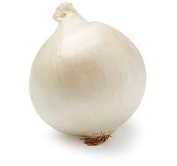
- 2 cloves garlic, chopped
- 2 carrots, sliced
- 2 stalks celery, sliced

Celery
See Store for Price
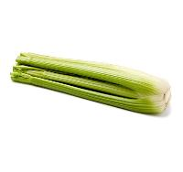
- 1 tablespoon minced fresh ginger root
- 1/2 teaspoon paprika
- 3/4 teaspoon ground cumin
- 1/2 teaspoon dried oregano
- 1/4 teaspoon ground cayenne pepper
- 1/4 teaspoon ground turmeric
- 1 1/2 cups chicken broth
- 1 cup crushed tomatoes
- 1 cup canned chickpeas, drained
- 1 zucchini, sliced
- 1 tablespoon lemon juice
- Add all ingredients to list

Directions
Add a notePrint
- Prep
10 m
- Cook
30 m
- Ready In
45 m
- Season chicken with salt and brown in a large saucepan over medium heat until almost cooked through. Remove chicken from pan and set aside.
- Saute onion, garlic, carrots and celery in same pan. When tender, stir in ginger, paprika, cumin, oregano, cayenne pepper and turmeric; stir fry for about 1 minute, then mix in broth and tomatoes. Return chicken to pan, reduce heat to low and simmer for about 10 minutes.
- Add chickpeas and zucchini to pan and bring to simmering once again; cover pan and cook for about 15 minutes, or until zucchini is cooked through and tender. Stir in lemon juice and serve.

You might also like
Moroccan Chicken with Saffron and Preserved Lemon
A wonderfully fragrant and gratifying Moroccan style dish.

Get the magazine

Get a full year for just $10!
Cook 5-star weekday dinners every time.

Nutrition Facts
Per Serving: 286 calories; 3.7 g fat; 27.9 g carbohydrates; 36 g protein; 67 mg cholesterol; 2128 mg sodium. Full nutrition

uygiuiuui

